**‘Being You’**

**The Self-Esteem Project**

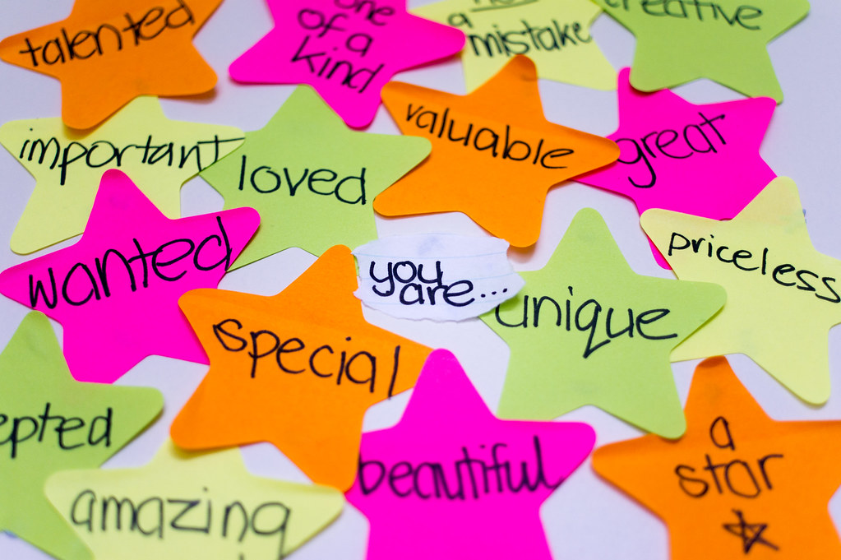

**A Programme for Schools and Settings**

**Created by staff and students from the Multi-Schools Council**

March 2024

**Contents**

1. Foreword Pg 3
2. Introduction to The Self-Esteem Project Pg 4
3. Session 1 – What is Self-Esteem? Pg 6
4. Session 2 – Self-Doubt Pg 10
5. Session 3 – Love & Belonging Pg 14
6. Session 4 – Brains Pg 16
7. Session 5 – Self-Talk and Growth Mindset Pg 18
8. Session 6 – Empathy and self-esteem Pg 20

**Appendices:**

Appendix 1 – I can, I am, I can be Pg 22

Appendix 2 - Self-Esteem Score Sheet Pg 23

Appendix 3 – Further Reading Pg 24

**Foreword:**

*“I am only one, but I am one. I cannot do everything, but I can do something. And because I cannot do everything, I will not refuse to do the something that I can do.”* **Edward Everett Hale**

I am delighted and thrilled that the Essex Multi schools Council has developed this self-esteem programme they have called ‘Being You’.

The concept of self-esteem has been written about from the time of the ancient Greek philosophers. Since then, it has been contemplated many times by psychologists.

Self-esteem is a subjective sense of overall personal worth or value. It describes a person’s level of confidence in their abilities and attributes. Other terms often used interchangeably with self-esteem include self-worth, self-regard, and self-respect.

Having healthy self-esteem can influence motivation, mental well-being, and an overall quality of life. However, having self-esteem that is either too high or too low can be problematic. Better understanding what your unique level of self-esteem is can help strike a balance that is just right for you.

We seem to understand now through the research that there are some key elements of self-esteem include:

* Self-confidence
* Feelings of security
* Identity
* Sense of belonging
* Feeling of competence

Having healthy self-esteem can help motivate you to reach your goals, because you are able to navigate life knowing that you can accomplish what you set your mind to. Helping our children to have a good level of self-esteem is very important. Engaging children and young people through this programme will help them to learn about some of the important aspects of healthy self-esteem. These sessions, where the messages and the themes are shared, will contribute to children and young people thinking and feeling differently.

I hope you enjoy using these materials enthusiastically within the programme in your setting as there is no doubt, we are all greatly influenced by particular people in our lives, whose messages about us can also contribute to our self-esteem. When these messages come from people, we value then we are likely to place more importance on them.

Best wishes

**Stephen Whitfield**

**Senior Educational Psychologist and SEMH Strategy Lead for Essex County Council**

*“When you're different, sometimes you don't see the millions of people who accept you for what you are. All you notice is the person who doesn't.”*

**Jodi Picoult**

**Introduction**

**How ‘Being You -The Self-Esteem Project’ came into being (by Kierran Pearce):**

The project was introduced based on feedback from young people following our resilience programme which you can also find a link to [here](https://schools.essex.gov.uk/pupils/social_emotional_mental_health_portal_for_schools/Pages/teaching_resources_semh.aspx) (you’ll need to scroll down to find The Resilience Project). From what we found, young people who had lower levels of resilience nearly always had lower levels of self-esteem too. We then worked with the Multi-School Council mental health ambassadors & young people across Essex to put together some inclusive activities aimed at improving and understanding self-esteem.

**What is self-esteem, and why is it so important?**

*‘Self-esteem is how we value and perceive ourselves. It's based on our opinions and beliefs about ourselves, which can feel difficult to change. We might also think of this as self-confidence.’*

We use these words within our mental health sessions in schools because they are words that young people, we have worked with seem to connect with. The **difficult to change** element is key and why we feel work on this area must start in schools, when young people are young! If we also look at Maslow Hierarchy of needs, it is the final layer before we get to the top of our triangles & so for young people to not meet this need it will certainly have an impact on them reaching their full potential.

More importantly than that if self-esteem needs are not addressed, young people are at greater risk of developing more severe mental health challenges, creating unhealthy relationships with their peers or at risk of becoming socially isolated. We know young people need to be in the right place to learn and without them having that self-confidence learning can become very difficult.

**Who is ‘The Self-Esteem Project for?**

The Self-Esteem Project is aimed at all young people from 8-18 years of age.

**How do I deliver ‘The Self-Esteem Project’ in schools and settings?**

The project is designed to be delivered over six hour-long sessions in whole classes of 30 or smaller groups of around 8 students as intervention. It is important to be mindful of student groupings in order to ensure it is a safe space where pupils are able to share their experiences and talk openly if they wish.

Any resources that are required are listed in the manual at the start of each session. There are delivery notes on the PowerPoint presentation itself, but these notes have also been replicated here in the manual for ease.

**What about pupils with SEND?**

The key ingredient in the making of The Self-Esteem Project is that it was designed by and for students with all needs and abilities. Therefore, it is user-friendly for all. Where we have differentiation suggestions, these are clearly marked in the manual.

**Feedback from children and young people who have completed the project:**

‘*At first I didn’t really want to be involved but the lessons were really fun, we played some games too and now I feel better about myself’.*

*‘I really liked being involved and now I am a self-esteem ambassador at my school so that I can help others learn how to be more confident and look after their brains too.’*

*‘I feel more confident from being involved and I feel like I can talk more out loud now about different things.’*

*‘The self-esteem stuff has helped me with my behaviour at school. Before doing these things, I used to get into trouble but now I think I can make better choices because we spoke about behaviour and our fight, flight, freeze brain.’*

*‘I like that we spoke about having a growth mindset. We used to talk about this in my primary school, but I haven’t really heard about it since. Having a growth mindset is helping me to think better about things like exams and relationships.’*

**Session One – What is self-esteem?**

The aim of this session is to ensure that the children and young people (CYP) have a good understanding of what self-esteem is, what it means for them, who are the important people around them and they impact they can have both positive and negative.

You will need:

* Enough mirrors for one each, or access to a larger mirror for a number of CYP.
* Handouts – I Can, I Am, I Can Be – Appendix 1
* Blank paper (A3 if possible) and pens
* Handouts – Score sheets – Appendix 2

|  |  |
| --- | --- |
|  | This programme was put together with staff and students from the Multi-Schools Council, Essex. This is a group of children and young people (CYP) from a variety of schools who come together regularly to have a voice in education.  Today we’re going to be looking at the following:   * What self-esteem is and how it can help us. * How to score ourselves to find out our current self-esteem levels, and at the end of the 6th session we’ll do this again to see if we’ve increased our self-esteem. * We’ll explore friendships both in and outside of school as well as the impact of social media. * We’ll look at differences between people in terms of individual needs. * Finally, there’s a chance at the end to ask any questions that you have.   This background image is by Kim Woodward who is a Multi-Schools Council Ambassador. She spoke to CYP about what self-esteem is about and she created this. Kim is visually impaired but managed to create this wonderful image. |
|  | In the session today we’re going to look at what self-esteem is, and what it means to you. We will start with a mirror activity then move on to look at things that we CAN do.  We’ll look at who is in our circle of friendship and talk about who we are as individuals. We’ll also consider the types of pressure we are all under.  Finally, we’ll score ourselves to see where our self-esteem lies at the start of this short course. |
|  | So we’ll start with this question – what is self-esteem?  *This can be a pair/group exercise with feedback, or CYP could respond individually with adult collating the answers. CYP could also be given post-it notes to write words on and add to spare wall or board to be feedback by adult. Decide on the best course of action for the group.*  Agree a shared definition of ‘self-esteem’. |
|  | This quote was chosen by a group of CYP in the Multi-Schools Council as they felt it reflected their views about themselves and their self-esteem.  What do you think? |
|  | *Mirror activity – each CYP needs access to a mirror. Bear in mind that this can be a challenging activity for some CYP. If they don’t want to use the mirror, they can draw what they think they look like.*  Look at yourself in the mirror. Use it to draw a self-portrait. You are NOT being assessed on your drawing skills – but use the mirror to do the best job that you can in 5 minutes.  *Wait 5 mins*  Great – now can we have some volunteers to share their drawings?  *Lead a discussion about what we can see, and what we can’t see – what’s going happening on the inside? How might that look on the outside? Can you look positive on the outside but sad inside? It’s a good place to bring up the idea of masking and hiding true feelings. Why do we do that?* |
|  | *Provide handouts I can, I am, I can be – 1 per CYP.*  We’re now going to look at these statements. Can anyone finish the first one…. I can *(take some examples – I can ride a bike for example)*  What about ‘I am’? That’s looking more at who you are as a person, so what example could you give? *(take some examples, such as I am a good writer or I am kind)*  Finally, let’s look at I can be statements. *(again, take examples – are they always positive? Do they always have to be? They might say ‘I can be annoying’ or ‘I can be successful in the future. Explore these with them.*  Now I want you to complete the handout with your own statements. Try to pick positive ones that will support your self-esteem, but you can add negative ones if you want to. If you keep them separate, you can keep those positive statements to refer back to when you’re having a challenging day. |
|  | *You will need the A3 paper and pens for this activity.*  This section focuses on who we have around us. Take your paper and pens and circles like this. Put your name in the middle circle.  We’re going to think about who we are closest to, and who we trust the most in our lives and put them in the first circle around our name. Who is in the circle? Best friends, parents, siblings?  In the next circle who are you adding? These might be your other friends, wider family, key adults like sports coaches etc.  It’s really important for all of us to have a good team around us and to know who these people are. How do those people in your inner circle make you feel? Are they all positive about you? Can some of them less positive? What is the impact of these people?  *Share ideas around the room. Remind pupils that sometimes we hold people close to us that are not always acting in our best interests in terms of supporting our self-esteem.* |
|  | Now we’re going to have a look at how we talk about ourselves.  In pairs, I want you to spend 5 mins each talking to your partner about yourself. You can talk about anything you like. Your partner will make notes by either writing key words down, mind-mapping, drawing pictures etc.  After 5 mins swap and do the same.  It can be hard talking about ourselves because we may not have a lot of self-esteem. Maybe we do, but we don’t want to feel like we are bragging. This is a safe space for you to share whatever you want without judgement.  *Take feedback from willing pairs.* |
|  | *Hand out the Self-Esteem Score sheet.*  I want you to put your names on the sheet and consider each of the arms of the score care. Use the scale to score yourself as to how you feel NOW in each of those areas. You don’t have to share your answers with anyone.  *Students can then keep them safe or hand them in as they’ll be needed at the end of Session 6.* |
|  | Are there any questions that have arisen today as a result of this session? Anything you’d like to know more about or discuss in more detail? |

**Session Two – Self-Doubt**

The aim of this session is to look more in depth at how we see things including self-doubt, the influence of external factors and how we can manage this.

You will need:

* Post-it notes (5-10 per CTP)
* 3 x A3 Paper around the with Past, Present, Future written on them.

|  |  |
| --- | --- |
|  | Last week we introduced the concept of self-esteem, looked at definitions (*ensure the group definition is displayed somewhere in the room)* and started to look at ourselves and own self-esteem. |
|  | In today’s session we’re going to move that forward by looking in more in depth at how we see things. We’ll look at self-doubt and how external factors can influence us. We’ll then look at a toolkit that helps to manage the outside ‘noise’. |
|  | *Ask students to respond to the question (a swan gliding peacefully).*  *Then ask what they can’t see (its legs working furiously under the water)*  So, the swan is able to glide on the surface looking calm, but paddling like mad underneath to keep afloat. How might this also relate to us? *Link back to the idea of masking or ‘putting on a brave face’ from last session.*  How might this relate to social media? Is everything we see in life is how it seems? *Invite discussion here about their own experiences if they wish to share.* |
|  | Look at these two images. *Invite discussion:*  What is the difference between them?  How has it been achieved?  Why might someone do this? What could this indicate about their self-esteem? |
|  | Now look at these images. What’s the key difference between these two photos? *Spots, skin quality/tone*    Why has this been done?  What message might this send to young people?  How might it make someone feel? |
|  | Finally, what about this?  Why might someone do this?  When you scroll through social media, do you consider the use of editing and filters? Do you use editing and filters on your own photos? *Invite discussion with those who are happy to share.* |
|  | *Stick up three pieces of paper round the room with past, present and future on. You will also need post-it notes (5-6 per pupil).*  Do you remember the I can, I am, I can be statements from last session? We tried to stick to positive statements, but we had a few negative ones creeping in. This is our self-doubt.  We use the word ‘self’ a lot because it’s about us. It’s ok to have doubts – everyone has them. They only issue is that, if we don’t address them, they can grow.  What self-doubts do you have? Do you know where this self-doubt came from?  Take some post-its and write your self-doubts on them (one per post-it). Then group them into past, present and future.  Put your post-it notes on the relevant sheet around the room. Remember – there is no such think as a silly doubt.  *Allow time for this movement. Then go to each board in turn and share some of the self-doubts. For each one, consider (or allow the writer to share if they want to) where these doubts have come from. Is it something they’ve seen or heard?*  What we’ve seen here is that some of our self-doubt come from things we’ve seen or heard. We need to think about the words we use to people and how they can have an impact on how they feel about themselves. It’s important that we explore how we feel about what we see and hear, then impact and where it comes from. |
|  | So now we’re going to look at communication.  In 2024 – how do you communicate with others? *Invite discussion – look at texting, photo messaging, voice messaging, emails, Insta, Tik-Tok etc.*  How much of your communication is face to face?  How many of you would rather text then talk to someone in person? *Show of hands a brief discussion.*  Is it easier to be unkind online than it is in person? Why? *Talk about having feedback from the person instantly via facial expressions and having to deal with the consequences of your actions immediately rather than behind the safety of a screen where you don’t see that impact.* |
|  | What do think of this quote?  How do you think self-esteem links with confidence? *Invite discussion.*  How does this link to social media? *Importance of likes/interaction even if it is just from strangers…* |
|  | *Ensure each CYP has a piece of paper and a pen.*  On your piece of paper, I’d like you to split it into 3 sections.  On the first section I want you to write: What do I value about me? Second section is What do I value about others? And the final section, What do others value about me?  *Give 5 mins for students to put some answers down.*  *Ask for feedback from those willing to share.*  Who found the last one the most challenging? Why is it so difficult?  If you haven’t managed to put much in that section, work in a pair or small group now so you can support each other in seeing what other people value about them.  Did anyone find out something nice that they’d like to share? Did anyone find out something surprising? |
|  | Now you’re going to create a personal toolkit to help you keep out the ‘noise’ and preserve your self-esteem.  Have a think about how you can protect yourself from negativity. There’s some examples on the board, but you can include your own too.  *Give 5 mins to do the task. If they are struggling, offer some examples such as ‘don’t compare myself to images that have been edited or filtered, or, keep away from negative people..’*  *Invite willing volunteers to share their ideas.* If whilst people are sharing you think ‘that’s a good idea!’ write it down and you can include it in your own toolkit. |
|  | Are there any questions that have arisen today as a result of this session? Anything you’d like to know more about or discuss in more detail? |

**Session Three – Love and Belonging**

The aim of this session is to explore the idea of our need for love and belonging. We also explore Maslow’s Hierarchy of Needs and ask the pupils to think about their own needs. Finally we finish with a guided meditation.

You will need:

* Dry-wipe board and markers
* A4/A3 paper and pens

|  |  |
| --- | --- |
|  | So far in these sessions we have introduced the concept of self-esteem, looked at definitions (*ensure the group definition is displayed somewhere in the room)* andlooked at our own self-doubt inside and outside of school. At the end of last session we looked at the importance creating a tool-kit of positivity to help improve our self-esteem.  In today’s session we’re going to move that forward and look at the importance of love and belonging, introduce you to Maslow and his hierarchy of need, then try some relaxation and meditation techniques. |
|  | *You’ll need a dry-wipe board with the work ‘Love’ in the middle and you’ll create a mindmap from pupil ideas.*  What is love?  *Get pupils to discuss and shout out some ideas.* |
|  | What makes you feel like you belong?  *Prompt responses by asking What groups are you in? Why? Who is in that group? Break down into why do you belong to this group? Consider friendships, sports teams, family etc. Why do we belong to groups?* |
|  | *Hand out A4/A3 paper and ask each student to draw a triangle on it.*  You may have seen this before. This is Maslow’s Hierarchy of Need. What Maslow says is that you need to work up from the bottom.  You can see at the bottom it’s our physiological needs – that means what we need to survive – food, water, shelter, sleep etc. Only if ALL of those needs are met, can we move to the next layer which is safety and security.  If our basic survival needs are met and we feel safe and secure we can move up to the area of love and belonging. Humans are social creatures, and we need to feel part of a group or community as we’ve learned already today.  Because of the secure foundations below us, we can enter the layer of self-esteem. We feel valued, loved, we feel like we make a difference to the world and we’re good people. This is the place we want to be.  And finally with all the pieces underneath us securely, we become the very best version of ourselves. The important thing to remember here is that we can move up and down the triangle. We might not always feel tip-top, but if we have that firm base below us, we can work our way back up again.  Now, on your triangle, draw the layers and fill them with your own needs – so for love & belonging you might have family, pets, netball team etc...  *Give pupils 5 mins for this activity and share some ideas from willing volunteers.* |
|  | What do we mean by self-care?  *Ask pupils to give some examples – ie taking time out to do something they enjoy, relax etc. Bring up the idea of mindfulness, meditation etc….* |
|  | Now we’re going to have a go at a short mindfulness/meditation session.  *Click link and watch video*  If you enjoyed that and would like to find out more, there are many videos, podcasts and apps that can guide you through meditation and mindfulness exercises. |
|  | Are there any questions that have arisen today as a result of this session? Anything you’d like to know more about or discuss in more detail? |

**Session Four – Brains!**

The aim of this session

You will need:

* 3 x A3 paper with writing on them: Fight, Flight, Freeze
* Art resources: mesh, foam, paint, wool, paper, glue, paper mâché, clay, plasticine etc.

|  |  |
| --- | --- |
|  | So far in these sessions we have introduced the concept of self-esteem, looked at definitions (*ensure the group definition is displayed somewhere in the room),* looked at our own self-doubt and considered our own self-care.  Today we’re going to look at how our brain works and then find out how to self-regulate. |
|  | *Make sure you have three posters around the room – Fight, Flight, Freeze*  When our body is under threat, or thinks it is under threat, there is a response that occurs built way back in our brains during prehistoric times. The purpose of this part of our brain is for us to survive. Nothing else…. Just to survive the situation we’re in.  The most common reactions to threat are:   1. Fight – where we get ready to fight our way out a situation 2. Flight – where we run away from that situation 3. Freeze – stand completely still in the hope that the threat will pass.   Our body does these things WITHOUT thinking.  You’ll see around the room there are three posters – one with Fight, one with Flight and one with Freeze. I’m going to read out a number of scenarios. Go and stand by the poster that best matches how you think your body might react:   1. You’re lying in bed, it’s dark. You hear a noise like there is someone outside your door. 2. You’re walking through a wood and a spider lands on your arm unexpectedly. 3. A large dog runs towards you – it looks aggressive. 4. You’re walking home alone, and you hear footsteps behind you. 5. You’re lying on the sofa half-awake and you hear the sound of a window breaking. |
|  | We spoke about this prehistoric part of your brain that keeps you alive. In this image here, it’ the ‘Downstairs Brain’. It is responsible for keeping you alive in every sense of the word. Reacting to threat but also the mechanical aspects such as blood pumping, eating, breathing etc.  At the top of the stairs is the ‘Upstairs Brain’ which we use to think through problems, control our bodies, show empathy, play etc. This is where we are logical and think through consequences and actions. But when we’re under threat (or our body thinks we are) we can’t get up the stairs to access logic. We are stuck downstairs and our brain will just keep us alive until the threat has passed, then we can climb the stairs and access the upstairs brain again. |
|  | *Pupils will need all the art materials for this part.*  Now we’re going to build a brain!  I want you to make a brain using the materials at your disposal. Start off by making the first part of our brain – the core function part – the bit that keeps you alive.  Then I want you to build everything else onto it that you need. Think about areas you use – self-esteem? Logic? Gaming? Physical activities? Think about what YOU need your brain to be doing for YOU.  Think about when you are in the fight/flight/freeze scenario. What would be helpful in those times to get you back up the stairs and into your thinking upstairs brain again? Build these aspects into your brain. |
|  | *Ask willing volunteers to discuss what they have added to their brain and why. Particularly draw out any areas that help support their self-regulation such as relaxation, calming down, self-care etc.* |
|  | Are there any questions that have arisen today as a result of this session? Anything you’d like to know more about or discuss in more detail? |

**Session Five – Self-Talk and Growth Mindset**

The aim of this session is to explore our own self-talk and the impact it can have on us. We’ll also look at Growth Mindset which some may already be familiar with.

You will need:

* A4 paper – one per student

|  |  |
| --- | --- |
|  | Over the past four sessions we’ve looked at self-esteem, self-doubt, Maslow’s Hierarchy of Need and we’ve looked at our own brains. Today we’re going to look at the impact of our internal voice – our self-talk and look at Growth Mindset.  At the end we’ll make a plan which we hope will improve our self-esteem! |
|  | What is self-talk?  What is NEGATIVE self-talk? What is the impact?  Where does it come from? *Draw pupils back to the self-doubt session where they looked at their circles of influence.*  Are you always kind to yourself in your self-talk? Do you ever say things to yourself that you would NEVER say to a friend? Why? |
|  | *You will need enough A4 paper for each student to have one.*  You each have a piece of paper. I want you to write your name on the top. Then pass it to the person next to you. Write down a positive quality about that person on the sheet. When you’ve done that, fold the paper so you can’t see what is written, then pass it on again until you get yours back with your name on.  Now have a look at the comments that have been written about you.  Anyone willing to share?  How has it made you feel?  Do you believe the things they’ve written?  Why/why not? |
|  | Growth Mindset – what is it?  In pairs I want you to discuss and come up with a definition.  *Share with group and agree a definition for the board.* |
|  | Now we’re going to play a game…  I’m going to read at a few scenarios and see how a Fixed Mindset would respond differently to a Growth Mindset.  *Go through each scenario and ask for examples of Fixed and Growth Mindsets.*   1. You audition for the lead role in the school play but you don’t get it. 2. You worked a long time on a piece of homework but you got a lower score than expected. 3. You forgot to take your shoes off and you’ve now walked mud all through the house. |
|  | To finish the session, we’re going to make a plan for a better mindset. Think about all the prior sessions and use anything you have learned so far – Maslow’s hierarchy, the brain you built, growth mindset and your upstairs and downstairs brain.  What will help you to remove your self-doubt, improve your positive self-talk and impact on your self-esteem?  Think about all the aspects you’re working on –  Instead of I can’t do this…. Maybe choose I can’t do this YET….. |
|  | Are there any questions that have arisen today as a result of this session? Anything you’d like to know more about or discuss in more detail? |

**Session 6 – Empathy and Self-Esteem**

The aim of this session is to bring together all the other sessions in order for CYP to understand how to develop their self-esteem.

You will need:

* WARNING – Pre-watch the video
* Score sheets from Session 1

|  |  |
| --- | --- |
|  | We’ve worked hard over the last five sessions to understand what self-esteem is and we’ve looked at our self-doubt, self-talk, the influence of others, the need to belong and how our brains can help us.  So today we’re going to bring together everything we have learned in order to help us to reach our targets and goals. We’ll also re-score ourselves to see how much our resilience has increased from when we did the baseline score back in session 1. We’ll start by looking at empathy. |
|  | What is empathy?  *Facilitate group discussion and ensure that all pupils understand empathy as well as the difference between that and sympathy. (Feeling WITH someone).*  How might empathy link to self-esteem? Can you/do you support others? Who supports you? |
|  | *WARNING – check this clip is suitable for the age group you are working with. There are some themes that may be difficult for certain individuals to watch. You may need to skip this video or find one that is more suitable.*  Here’s a short clip that explains what empathy is. |
|  | This sums up empathy in a way that reminds us to think from the perspective of that person. |
|  | Now let’s recap all the sessions we’ve done. There’s some prompts on the slide….  *Ask willing volunteers to explain what was learned from each of the images. Feedback and emphasise the link to self-esteem.* |
|  | Now let’s go back to when we scored our self-esteem back in Session 1. Re-score yourself now based on what you’ve learned.  How much self-esteem do you have in comparison to when we first scored ourselves? Maybe some of the work we’ve done over the last five weeks has increased your resilience.  *Allow time for this activity.*  Now I’d like you to speak with a partner and show them where you have really improved your self-esteem in comparison to before this project. Are there any areas where you are ‘stuck’? If so, what can you do about it? Think about self-care, Maslow’s pyramid and your work on self-doubt.  *Allow time for this and ask CYP to report back on their progress.* |
|  | Are there any questions that have arisen today as a result of this session? Anything you’d like to know more about or discuss in more detail? |

**Appendix 1 - I Can, I Am, I Can Be**

**I can ride a bike**

**I can swim**

**I can solve a sum**

**I can write my name**

**I can use a phone**

**I can turn on the TV**

**I can use an iPad**

**I am kind**

**I am helpful**

**I am a fast runner**

**I am trying my best**

**I am happy**

**I am thoughtful**

**I am friendly**

**I can be helpful**

**I can be kind**

**I can be anything I want to be**

**I can be positive**

**I can be a good friend**

**I can be a good person**

**I can be a role model**

**Appendix 2 - CYP Self-Esteem Score Sheet/Scale**

NAME: ____________________________

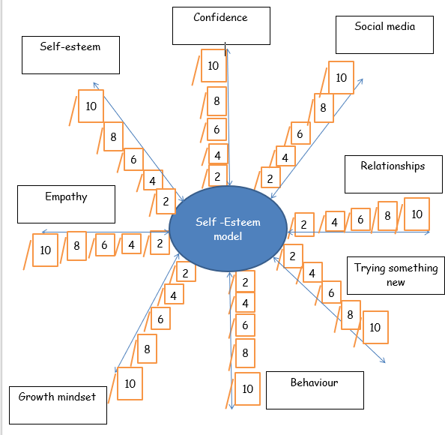

**Appendix 3 - Further Reading and Helpful Links**

<https://www.multischoolscouncil.org.uk/>

<https://www.mind.org.uk/>

<https://www.listennotes.com/podcasts/time-out-with-connell-co-connell-scholar-lpS4y1buFGA/>

<https://mhfaengland.org/>

<https://education.gov.scot/improvement/learning-resources/compassionate-and-connected-classroom/>

<https://www.youngminds.org.uk/>

<https://www.headstogether.org.uk/>

<https://www.kooth.com/>

<https://www.minimemindfulness.co.uk/guided-meditation>