The Multi-Schools Council | 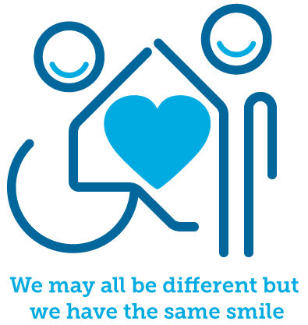

July 2024

Annual report


Introduction  Welcome to our first ever, full annual report from the Multi-Schools Council (MSC). It has been another tremendous year of growth. We do wish to start by thanking Essex County Council for supporting & sharing our aim of improving the ability to connect with young people and respond to their priorities. In particuar we wish to thank the Essex Youth Service for giving us a home and now the SEND participation and strategy team for taking us in.  This report will outline the three key pillars of our work;  - Engagement meetings  - Schools based delivery  - Ambassadors  What we hope to demonstrate through this report is the impact our work has had, the work still to be done and the common themes amongst young people within Essex. Our work truly is about partnerships and no matter what sector we operate within, listening to those on the ground who ‘feel it’, ‘see it’ and ‘hear it' is the only way we can really get a grasp on reality.  Kierran Pearce, Multi Schools Council Lead | 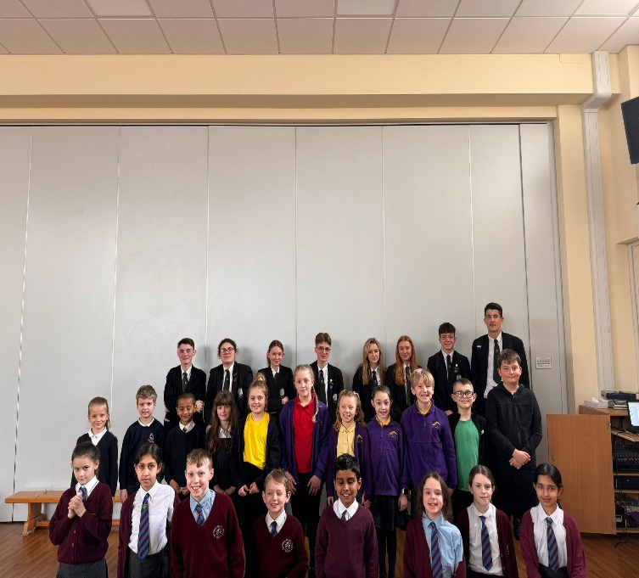

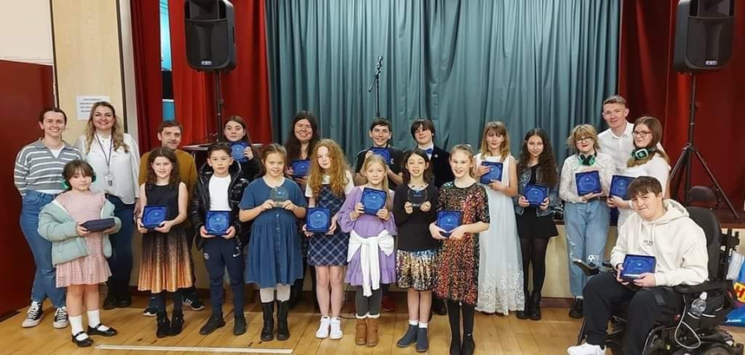

Engagement meetings

What are they?

Our MSC meetings or engagement meetings are oppertunities for young people across Essex, regardless of age or setting, to have their voices heard. Agenda’s are based on themes picked up via our ambassador team of young people or by things we hear when visiting schools or other child and young people based meetings.

This academic year we set out to hold engagement meetings every half term as requested by young people. This moved away from our traditional termly meetings quite simply because young people wanted more of them! Meetings are held in person, although we do allow some virtual meetings for schools/small groups who don’t want to miss out. This year, meetings happened in 8 different areas:

Colchester, Tendring, Braintree, Chelmsford, Basildon, Brentwood, Harlow, Uttlesford.

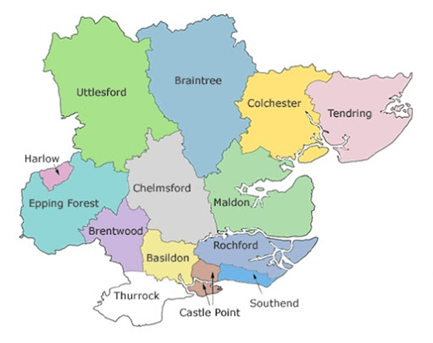
We also have two further meetings, one in North Essex & another in MID Essex specifically for secondary schools/colleges because of high engagment numbers.

Data

Our meetings have included young people between the ages of 6 to 19. This means up to 1,399 young have attended those meetings between September 2023 and April 2024. Due to feedback gathered by schools we postponed our May meetings, this was based on pressures with exams and host school challenges, including staffing numbers.

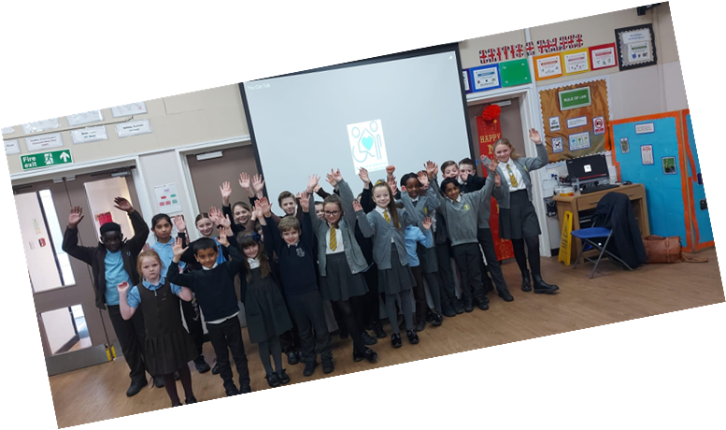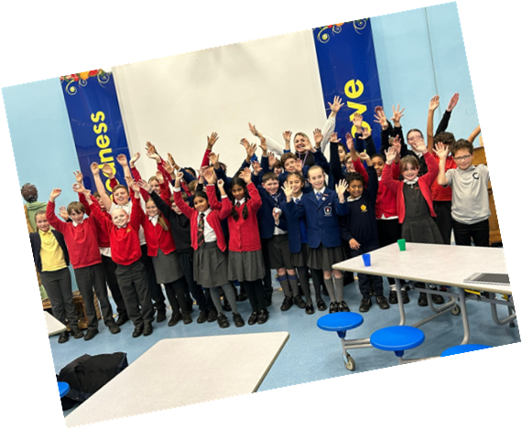

The meeting topics – With all our topics you can read individual meeting meetings via our website which is referenced at the end of this report.

School transitions between year 6 to year 7 was something that has been raised by young as becoming increasingly challenging during the summer of 2023. Young people gave their thoughts on what would better support this process:
- More transition days.
- Better advice around ‘it’s okay to ask for help in secondary school.’
- Maps of the new school.
- More opportunities to meet various teachers.
- Better peer to peer support – use older students to support younger ones.
- Adopt a trusted adult, every young person should have one.
- Access to art resources to help young people express themselves.
- Make sure the end of year 6 is a celebration.
- Information booklets about the new school to be child friendly.
- Make sure teachers understand individual needs.

Communication was listed due to the on-going work around the balanced system and looking at an Essex universal offer. Comments gathered looked at what helped young people to express themselves and what might prevent them from doing so.

What helps | What prevents
Worry boxes – although they need to be checked | When young people don’t feel listened to.
Having art resources available. | Not having a trusted adult to speak to.
Having a safe space in school to go to. | Challenges with friendships.
Buddy benches/play leaders. | Being forced to sit and talk.
PECS and other symbol cards. | Poor communication from adults.
Walking & talking.
Mini-Whiteboards.
Emotion boards.

Young people also wanted to discuss Exams and their general thoughts about them. This resulted in a full exams report which can be found on our website (referenced at the end of this document). The group also wanted to focus on fundraising for our work to improve our impact within the local communities and gave lots of ideas on how different schools could approach this.
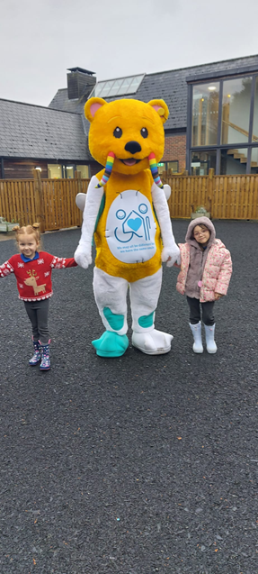
As Christmas approached, we used the meetings to also formally introduce our new mascot BANJO which was designed within these engagement meetings. BANJO represents diversity at all levels and will help young people further connect with the MSC.

Anxiety was becoming a buzz word among young people we spoke with and so we wanted to understand this further. They key question focused on what anxiety means to you and your friends:

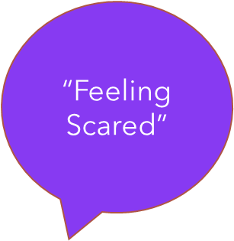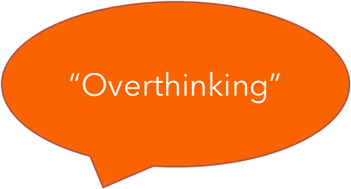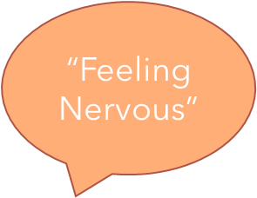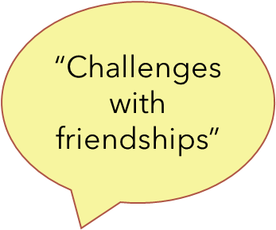

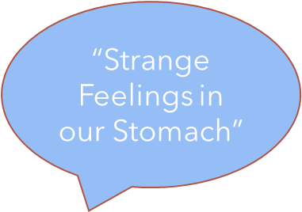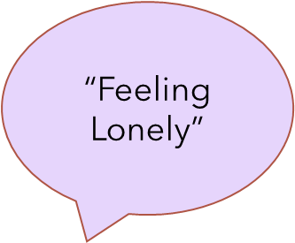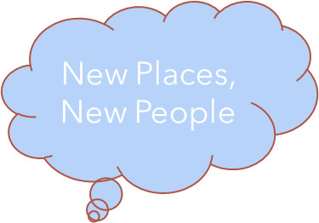
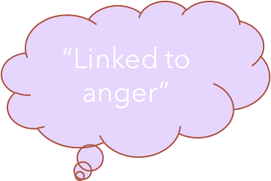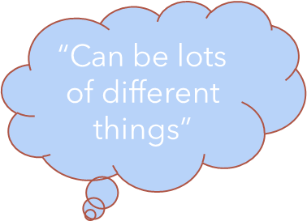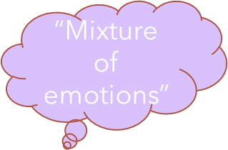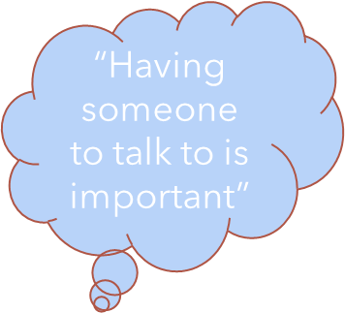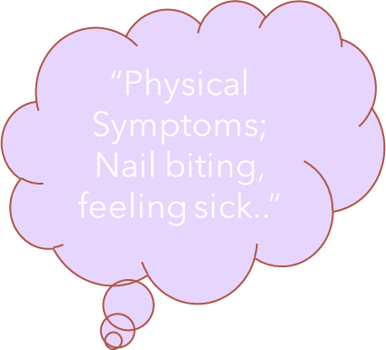

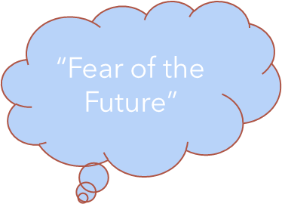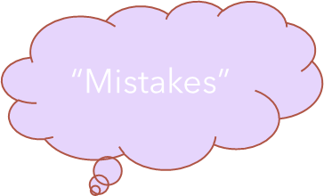

Banjo was discussed further within these meetings as young people gave their thoughts on how our mascot could be used to further share awareness. Ideas included badges, mini-banjo teddies, find different ways for banjo to communicate, banjo social media page, some posters, get them attending events, visit different schools and produce a tag line!

Young people were also keen to talk about outdoor learning & the benefits vs the disadvantages. This resulted in a presentation being created which can be shared on request (see reference list for details). The PPT also includes a short piece on links to sensory needs.

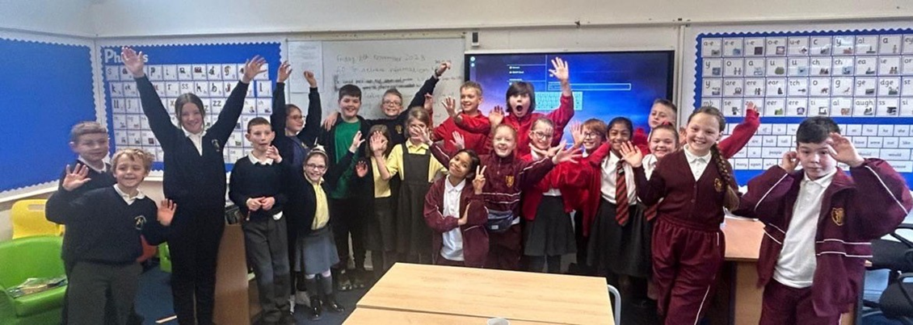

Separately Physical Activity was also another hot topic among young people. What this question focused on was what might prevent young people from being active and what might support them. Keeping active was chosen as a key focus area for young people in September 2021 and so has featured heavily in different discussions over the past 3-years. The team decided to produce another presentation based on this feedback (see reference list).

Coming into 2024 our new song, written to help support young people better understand our mental health, was released to schools. You Can Talk is aimed at early year provisions and was written by gathering views through 2023 from young people (see the reference list for a link to the song). The growing pressure on family finances was also being felt by young people and so poverty became a focus topic within the meetings. There were some suggestions and ideas on how support more families:
- Free schools' meals for all.
- Further reduce the costs of uniforms.
- Use schools as hubs to donate clothing & toys.
- Raise awareness of food banks in schools and help shift the negative stigma.
- Use non-uniform day donations to better support other young people.
- Have more books and other resources available for young people.
- Every school to have a breakfast club.
- Snacks for all young people but especially those from low-income families.

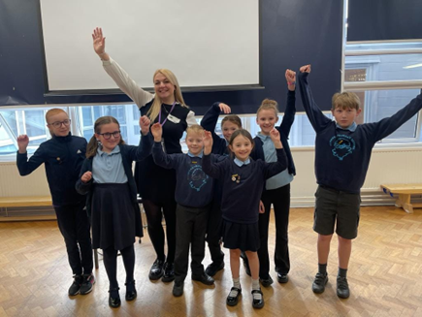
The group also took a crucial vote in this round of meetings, looking to set the key focus areas for the next three years (from September 2024). After gathering a long list of priorities from young people the vote was then based on 15 different areas. The voting then took place with 3 resulting focus topics:

ADHD
Crime
Mental Health

Improving the national curriculum was also discussed which gives some interesting local insight into what young people want to be learning about further. This was then put into a report which can also be requested (see reference list). Our young ambassadors are also keen to improve engagement among schools & young people. One of the ways they wish to do this is through board games and so an interesting discussion point was what are young people’s favourite board games.


What does inclusion mean to young people? That was our next focus moving towards Easter. We are engaging in several projects linked to inclusion and therefore we have been able to create a detailed presentation. As part of these meetings however we also gathered some videos from young people-based on their feedback and these can be found on our YouTube channel (see reference list).

How technology is viewed among young people was also discussed. What the conversation captured was the good vs bad when it comes to technology and the team decided to use our social media channels such as Instagram to help share these thoughts further. In addition to technology the group wanted to talk about reading and more specifically what encourages/supports more young people with their reading:
- Having more books available in schools.
- Use technology to support those who find reading difficult.
- More picture books for older age groups (secondary schools).
- Better support for those who may be dyslexic.
- Use peer to peer reading schemes such as older children reading to younger children.
- Use more dedicated spaces in schools to allow them to read.
- Encourage don’t ‘force’ young people to read.
- Provide rewards for reading and reaching certain ‘milestones.’
- Have more audio books available.
- Reading can really help with spelling.
- Books that get you thinking are more popular.

The final area recorded in this year’s report for our engagement meetings is happiness. Young people had been identifying low levels of happiness amongst their peers which is probably reflected in mental health becoming a chosen topic for September. The feedback from these meetings was then gathered in an improving happiness report (see reference list).

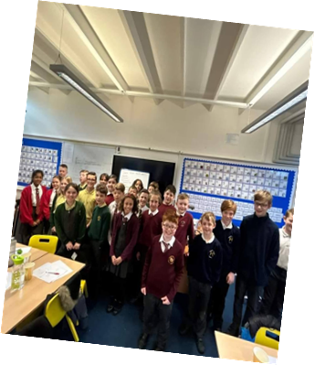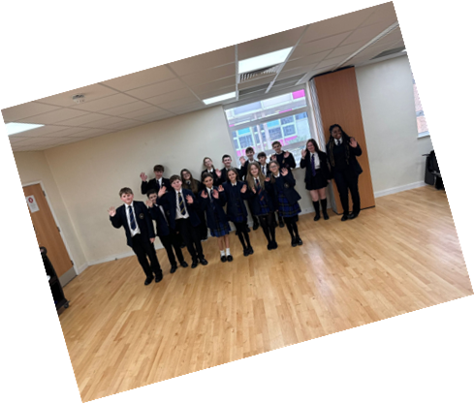

Actions & Impact – Following each round of meetings the minutes are shared with schools, published on our website and a highlights PPT is also created.

- School’s transitions – This feedback has been used by our team of ambassadors as part of a transition mentoring session and was delivered in spring 2024 to just over 100 young people across each of the 4 quadrants in Essex. Further positive feedback has been gathered from these sessions with a full review meeting planned, with a view of rolling this out further in 2025.
- Communication – These thoughts were presented at an autumn SET therapy meeting & recorded as part of the on-going piece of worked linked to the balanced system & it’s universal offer.
- Exams – Full report shared with schools in good time before the official exam season.
- Fundraising – A full fundraising week has been created based on this feedback & will feature within the next annual report (2024 – 2025).
- Anxiety – We have updated our mental health staff CPD session based on this feedback. The true impact of this will be recorded in our delivery as part of the new academic year.
- Banjo – A poster competition was launched, and a winner has been chosen. Banjo has also visited several schools. The other ideas are all in progress.
- Outdoor learning – PPT shared with schools & now features as part of our awards in school’s programme.
- Physical activity – The report has resulted in a presentation to the transforming care board with some actions taken away & delivery of another presentation at the annual Active Essex PE conference to help inform school practice.
- Poverty – The report has been shared with local MPs across Essex but has been stalled due to the general election in July.
- VOTE – The work on these priorities will start in September and they have been positively received by the young people we work with directly.
- National curriculum – This report was shared with the department for education.
- Board games – Plans are being developed with our ambassadors about how some engagement events can be rolled out in the new academic year.
- Inclusion – The inclusion PPT has already been used as part of an initial teacher training conference and we are now looking at how this information can be incorporated into the current inclusion reviews and wider inclusion strategy.
- Technology – The information gathered was put into a small social media campaign through our reach, using a video reel and shared with young people in our network.
- Reading – Feedback has been shared with 3 national organisations focusing on improving reading resources for young people with different needs and we hope to start to see some of the impact of those.
- Happiness – The report has been shared with schools & will also be monitored as part of our awards programme.

What’s coming up

- School SENCO’s – What role do they have & what would you like them to do?
- One plans & EHCP’s – How should/would young people like to be involved in their plans?
- Mental health awareness – What could this group do to help support young people’s mental health?
- ADHD awareness – How to build better understanding in society?
- Crime – Why is crime one of young people’s main priorities?

Other key topics will be identified through the summer and into the autumn.

Conclusion & Overview – Engagement meetings

Our meetings have developed this year based on feedback in 2022 about how they could be improved. This has resulted in a more structured introduction brining in different elements of work, breaking the meetings up with games and providing a better feedback document for schools after each engagement meeting. Looking at the data, this has been our best attended year on record but the caveat with that is that we have also conducted a higher number of meetings. However, we have seen an increasing trend of growth in areas such as MID & WEST Essex which have historically struggled compared to numbers in NORTH. There is still work to do in SOUTH Essex to help improve engagement numbers.

In 2024/2025 will be moving to 4 engagement meetings rather than the planned 6 this year based on feedback from schools about the pressure of not just getting to so many meetings but also responding to the feedback. In addition to this we will be splitting the meetings into a full district model which means the areas of Castle Point, Rochford, Maldon and Epping Forest will have their own dedicated meetings, hopefully gathering a better local feel and reducing travel times for young people & schools. We think from evaluating the topics discussed that school inclusion/improvement is a central theme to many of the discussions. This will help to shape our focus in terms of where we best use our capacity and how it will link into our wider strategic plan.

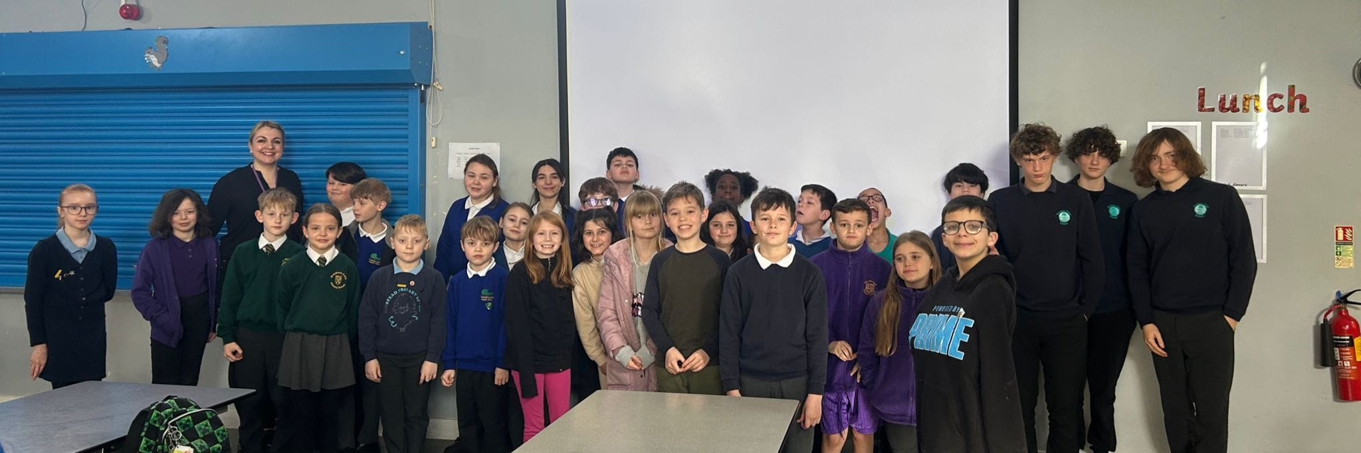

School delivery sessions

What did we have on offer?

All our school delivery sessions have been designed with young people over several years and then developed using our own SEND knowledge, working alongside strategic leads within the local area both from education & health services. We have an offer for young people which includes the following:
- Autism awareness workshop
- ADHD awareness workshop
- Mental health assembly
- Anti-bullying assembly
- SEND assembly

(For more information on these sessions see the reference list)
In addition to the young people’s offer we also have a staff CPD offer which includes:
- Understand to support – Autism awareness
- Early intervention strategies to support mental wellbeing – Mental health (in two parts)
- Speech, Language & Communication – Whole school approaches

(For more information on these sessions see the reference list)

Separate to our core offer we have also developed a self-esteem programme which is now in a manual format available for all schools and features as part of the Trauma Perceptive Practice offer, within the HIVE platform. A special mention to the Essex SEMH team for their support with this project and ensuring the manual could be produced.

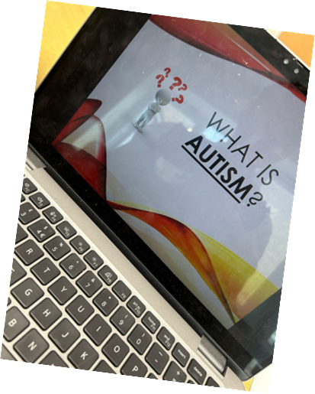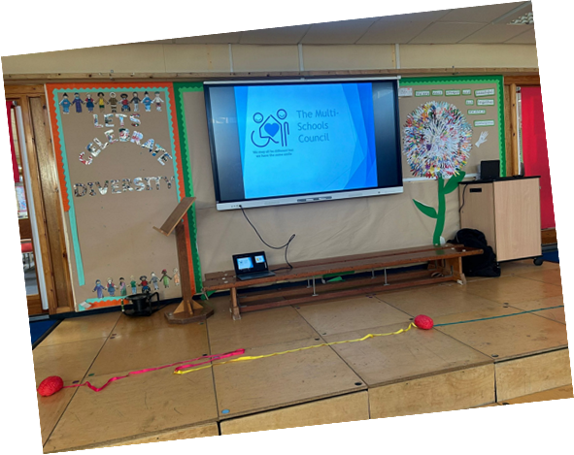

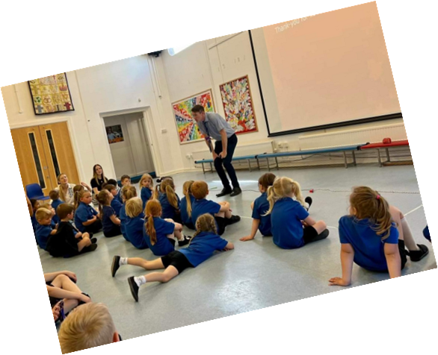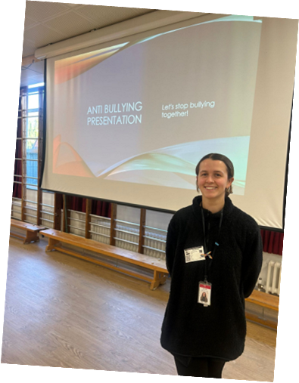

Data

Feedback

What did young people take away from any of the sessions?

‘Firstly, they really enjoyed them. Secondly, it was great that the MSC staff shared their own needs which makes them very relatable to our pupils. They are also great role models.’

‘A better understanding of difference between young people and how to support each other. Importance of looking after our mental health. What bullying is and how to report it, what to do to help.’

‘How the values of MSC links extremely well to our school vision "Unlock every child's potential as a unique child of God. Children respond well to having different topics covered that they can relate to and share their own opinions on.’

‘This is part of a continuous 'drip feed' approach to supporting neurodiversity in school. Amy and Kieran have both delivered assemblies and workshops in school. Many of our children have reflected on themselves after these events and have gone home to talk to their parents.’

‘The children could relate to the message given and it was set in a context that they could understand. It linked to previous assembly messages. Also Kieran linked it to the song that was played 'the power in me' which has a strong message. One child asked about becoming a MSC ambassador.’

What did your staff take away from any of the sessions?

‘The staff found the session helpful and added to the other wellbeing aspects we have covered. It
stimulated discussion but also change; as a result of the meeting two staff members met to discuss a way forward to circulate more wellbeing support material.’

‘This was a very interesting and informative session. It gave us a good opportunity to reflect on our practice and strategies that could support our young people. Amy Gair who delivered the service was excellent.’

‘That we are already implementing a lot of strategies to support the Menta Health of our pupils but there is still more that we can do. Learning about the resilience Manual was helpful - we have already downloaded it and have planned to implement it with a group of young people in the summer term.’

‘An awareness of some of the issues that our students with Autism might face in the classroom.
An understanding that students will autism are all different and have different needs.
An appreciation for some of the barriers.’

‘It was very interesting to hear the children's perceptions on SEND and we may consider setting up a group of children to discuss SEND in the school.’

There is further feedback from all the sessions via our social media pages coming directly from young people and help us to get an even better idea about how our sessions have been received (see reference list for details on YouTube, Facebook and Instagram). You can also access further feedback videos via our website (see reference list).

Conclusion & Overview – School delivery

This is the first full academic year we have been able to put a consistent team in place and deliver sessions to schools and this has made a big difference. Our two newest additions of an anti-bullying assembly & a staff speech/language session have been well received. We have however reviewed the overall impact of sessions and will be using the anti-bullying assembly more sporadically targeting anti-bullying weeks and special events. To enable more targeted delivery, we are also ensuring that if schools want a mental health assembly from us, they must also book an autism or ADHD workshop at the same time.

You will see over the two terms of delivery there were 211 sessions completed and although North Essex still leads the way in terms of numbers, we have seen the biggest increases in both South and West Essex. Our Mid Essex offer has been highlighted and we have plans in place to increase uptake in this area from the new academic year. Team leaders Kayleigh & Amy will now be responsible for specific areas which will give us more of a balance countywide. 38% of our delivery was also within secondary schools, with our previous highest being 14%. We must thank the Essex Youth Service for their support in creating links in this space and have found building connections with Multi Academy Trusts a useful way to link our work into some Secondary schools.

The feedback collected is really pleasing and is just a flavour of what has been collated this academic year, for further evidence of this please contact us separately (see reference list). One of our questions focused on what future sessions young people and school staff would like as part of our offer and here are the most popular responses:

- SEND/Neurodiversity in mainstream schools – strategies
- More of a mental health focus
- Pathological demand avoidance
- Physical differences
- Oppositional defiance disorder

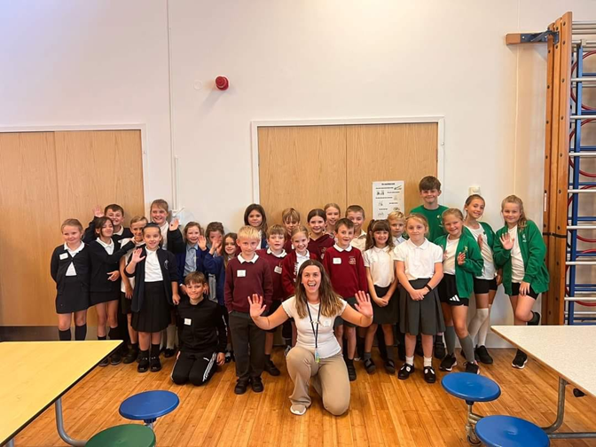

‘Keep being fab!’
‘Thank you - it is nice to have different speakers into school but also messages that are designed/ created by other students.’

‘Kayleigh was professional and relatable!’
‘Well-presented and great information provided.’

‘Thanks for providing such a great, free service to SEND.’

‘The staff felt both assemblies were engaging and informative. The children wanted to continue the discussion back in class. We all liked the focus on what children can do rather than what they can't do.’

‘It has been fantastic to see the confidence of the children attending grow throughout the sessions and lovely to see how all the children attending respect each other and interact with children they wouldn't normally speak to during the sessions.’

‘Multi Schools Council is just amazing and so valuable.’

‘Thank you! We are lucky to have access to this wealth of knowledge, especially at no extra cost to school.’

Ambassadors

What are ‘ambassadors?

Our ambassadors are mainly young people that have either been selected or applied to take on extra responsibility and roles to achieve our mission of challenging negative perceptions towards those with SEND or mental health challenges. This means that not only do some of them represent the schools they attend but they also engage with us and other groups outside of school online or in-person at various events. Each ambassador gets to choose what they wish to be involved in, as we offer 19 different working groups all linked to our mission.

How many do we now have & where are they from?

We now have 156 ambassadors:

Individual work/achievements

Speaking at the PACT Annual Ball

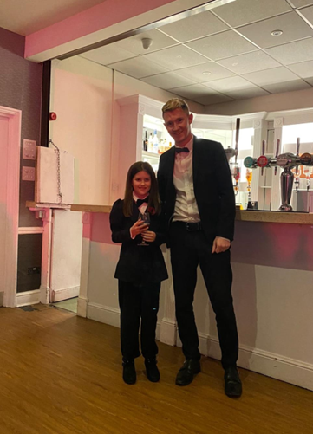
Eva was the guest speaker at a special Essex charity ball for the wonderful charity PACT (see reference list). Their theme for the ball was James Bond & Eva fantastically wrote a poem about her brother Luke, who has a diagnosis of autism, & gave her opinion on what Luke would be like for a day as James Bond. Eva helps to advocate for her brother and has helped inspire our focus on siblings of those with SEND as their voice is also crucial in terms of making sure we understand different children.
Awareness Calendars

Sticking with Eva she was also able to help inspire and led the creation of some awareness raising calendars, that were sold both online and in-person. On one day she sold over 100 calendars at County Hall in Chelmsford so when you are their next you may see some of them about in different teams! This has helped spread awareness of our work across Essex but encouraged over 20 children to get outside and take pictures of places from across Essex.

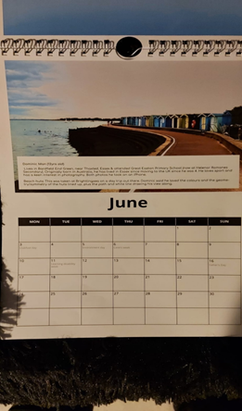
Dyspraxia & a national TV appearance

Freya from West Essex helped deliver a special dyspraxia lesson within her year 6 class giving them lots to think about when it came to understanding this need. Freya has been so impressive in her delivery of this that she has worked with the Dyspraxia foundation (see reference list) & was then asked to appear on the One Show, airing on BBC One in early 2024! This was a massive achievement for Freya and she has left behind a legacy of awareness within her primary school.

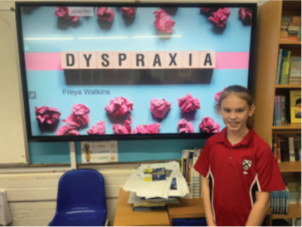
Fundraising and mental health awareness

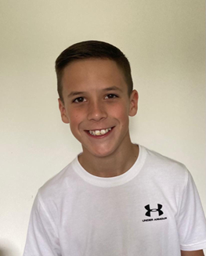
In the last academic year our ambassador Ryan gave an emotional speech about autism and some of the challenges that can impact on young people’s mental health. Ryan’s speech has been used across health services for learning but since then he has also gone even further raising over £1000 for charity and helping to give more young people a voice.

Spreading our wings

This report is very much based on our work within the Essex local authority however we are now working closely with surrounding local areas. As part of this our ambassadors are keen for our work to move more directly into other areas. Our ambassador Gabi, who attends a secondary school in Southend, has driven conversations with partners in Southend which has resulted in funding being allocated to develop a similar model. ‘Young people don’t see local authority boundaries’.
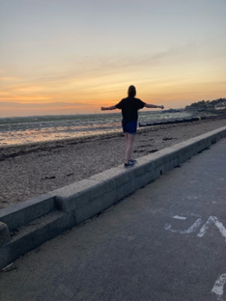
Supporting the homeless

One of our fundraising members Tilly helped inspire local support for the homeless. This resulted in several items being donated to a homeless shelter within North Essex and has inspired ambassadors to follow this up and support their local areas too.
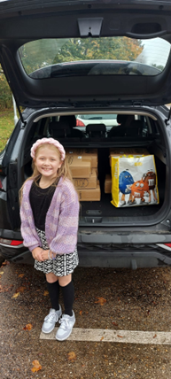
JP winner!

Jake was a very deserving winner of a Jack Petchey award because of his work as a MSC ambassador! Jake has helped drive forward our ADHD group with his awareness about school life and taking medication. In a very kind gesture, Jake donated his winnings to the Multi-Schools Council!

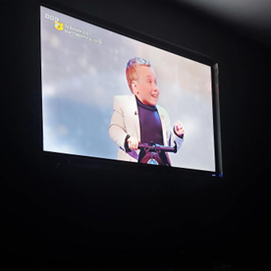
Did you watch Children in need 2023?

We feel very proud to work with Lenny, who became the first ever child presenter of Children in need! Lenny attends a Secondary school in Mid Essex and is also passionate about challenging negative perceptions. Lenny continues to join us for meetings online in between his now global acting roles!

I have found my pack!

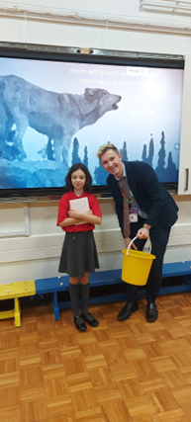
Another ambassador creating their own awareness session for a whole primary school in West Essex as part of an assembly. Lois spoke to her school about autism through a wonderful story she has written about a wolf with autism. The school have commented on how young people & staff have continued to discuss this awareness following the story in what was also a massive achievement for Lois. The story is so good we are currently looking at how this could be published. Lois’s closing line was ‘Thank-you to the Multi-Schools Council ambassadors for helping me find my pack’.

Another JP winner!

Jonathan, who has now been an ambassador for several years, also won a Jack Petchey award for this work with us and his work with other youth organisations as he is an active member of the Essex Youth Assembly. Jonathan has helped influence many projects, is the team leader for our autism group and is trying to drive forward changes in home to school transport arrangements.

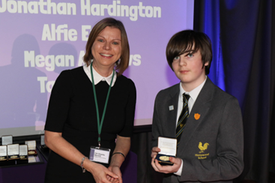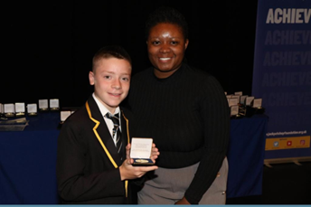

National child hero finalist

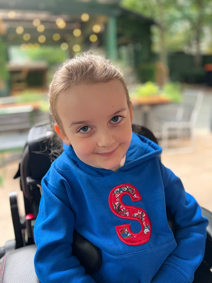
Our ambassador Sophia was a finalist at the first ever National NHS SEND awards after being put forward for her awareness work as part of the Multi-School Council. Sophia does a lot of learning from home due to her health conditions and has helped with raising awareness on this subject. Sophia also creates a lot of awareness online about her condition and we are very proud to be working alongside Sophia.
OCD awareness

Another young man creating awareness in and outside of Essex. Owen has been involved in a regional speaking competition after choosing to educate his class within a Mid Essex secondary school about his challenges with OCD. Owen is also a big advocate for his sister who has multiple needs and is continuing to work with other ambassadors to educate them too.

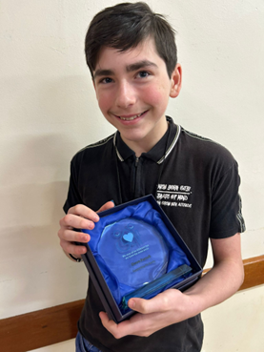
Talent and selective mutism

Daisey-Mae has not been an ambassador for as long as some of the other young people you have heard about so far, but she has already had a big impact with her ideas. In the middle of 2024, Daisey-Mae ran a talent show to help raise awareness of selective mutism. We are now all learning more about this and she has plans for an even bigger show in 2025 so watch this space!
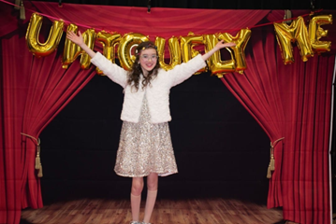
Delivering a national award

Dilly has now been an amazing advocate for the whole of Essex over several years and this year she helped present a national award as part of her work with us. Dilly is a great speaker and is continuing to build awareness, especially about girls with autism.

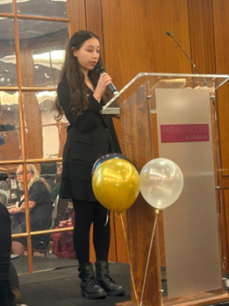
Autism awareness assembly

Inspired by some of the other ambassador’s work, Grace also delivered a whole school assembly on autism which she helped design. Following the assembly Grace says, she feels much better understood by her friends and staff, leaving behind a legacy again before she moves onto Secondary school.

Cleaning up Essex!

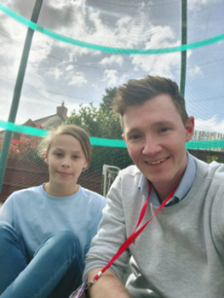
TJ is passionate about looking after the environment and in his role as ambassador he organised a local litter pick, even getting his friends involved! The group braved the elements and headed to Great Notley Country park to pick up people’s litter! Not only did TJ get young people up and moving, he helped spread awareness of ADHD and has inspired other young people to look after their local areas too.

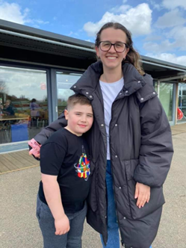
Taking our work to parliament

Dilly has already been mentioned but here she is again taking our work wider than just Essex. Dilly is also a talented artist and won a competition ran by the national autistic society (see reference list) that featured her autistic friendly school. Dilly has helped use this learning in many different local teams across Essex which are referenced later within this report. Dilly had a day in Parliament with her local MP and has since got them following our work via social media!
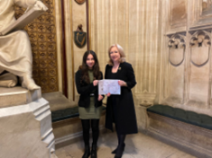
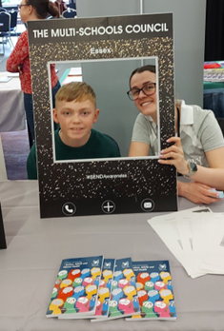
Regional youth voice

Leo is another ambassador who has helped spread awareness of our work at a regional level. Leo led a presentation to young people and adults across Suffolk, Norfolk and Cambridge about why listening to young people is so important and how it can be done in different local areas. Leo has taken this back into his West Essex school where he is influencing improvements in their own school council.

ADHD awareness in school

Following up with his heroics cleaning up the local area, TJ also ran an ADHD awareness session to his whole class. TJ worked hard to put this together so that his friends can understand how his brain works in different ways.
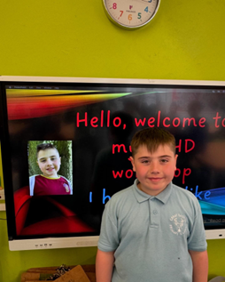

Sensational performance

And finally….our ambassador Jacob gave a memorable dance and signing performance to over 400 people at our annual Invincible games event. Jacob is a young man who attends a specialist provision and is deaf but has wonderful rhythm and a passion for music. We know from the reactions that Jacob inspired many people on that day in June.

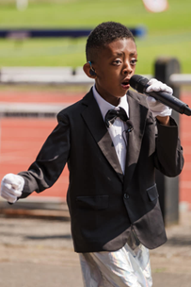
Group work

- School transition workshops – In the summer of 2023 young people identified a growing need to support others when transitioning between primary and secondary schools across Essex. Issues had been raised around secondary schools dismissing plans from primary schools and young people feeling isolated once settling into a new school. 10 of our ambassadors, all of whom had experience of transitioning put together an hour-long workshop which was then delivered in-person and virtually in every quadrant across Essex. Feedback from year 6’s and staff within different schools has been very positive and the group plan to build on this for the new academic year, with plans on how to enhance the sessions.
- Trainee teachers – During the summer term several of our ambassadors spoke about what inclusive teaching means to them and recorded some powerful messages which can be found via our social media pages (see reference list). These videos were then used at a teacher training conference across Essex, Suffolk and Cambridge as part of a whole day focusing on inclusion.
- ADHD play – Our talented performing arts and ADHD groups have combined to put together a play all about challenging the perceptions towards ADHD. The cast for the play has now been filled after several weeks of auditions and involves ambassadors from across Essex and new young people who are yet to be involved with us. The plan is to perform the play in 2025.
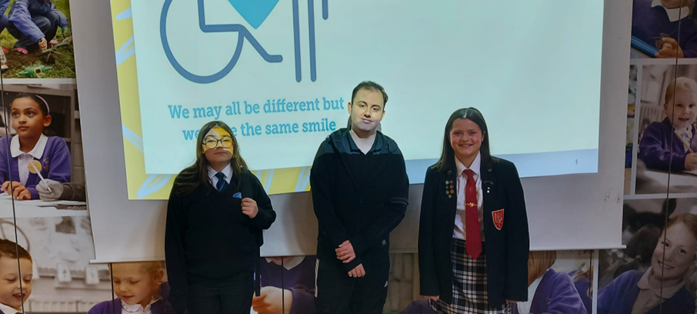
- Autism outreach service – Three of our autism ambassadors took on a leading role to help launch a new autism outreach service through the transforming care agenda in Essex. The ambassadors helped share what they felt a good service should look like, they then evaluated different bids to lead the service and will now be involved in helping to review the service once it is up and running!
- New resource – Staying on the theme of autism more of our ambassadors helped the charity KIDS (see reference list) to launch a new resource aimed at supporting other young people with autism. Some of the group were even involved in some filming which has now resulted in the KIDS autism hub which can be found on the Essex local offer (also on the reference list).
- Essex teaching awards – In late November two of our ambassadors gave amazing speeches, which can be found on our social media pages, at the 2023 Essex teaching awards. Both were inspirational and gave all those in the room aspects to reflect on when it comes to the language we use within SEND education & how to successfully promote aspirations for young people with differences.

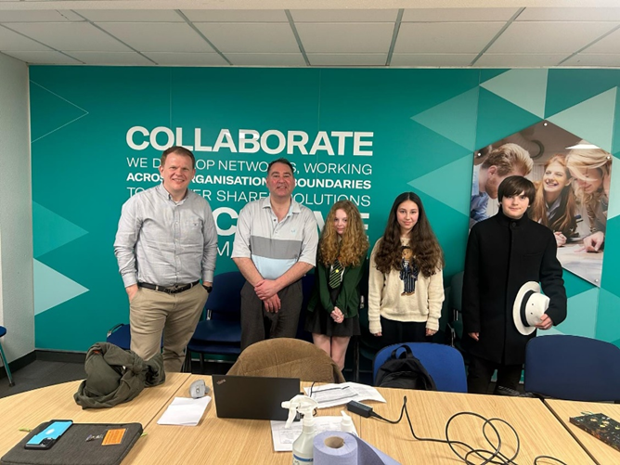
- Youth service takeover day – Two ambassadors helped represent the multi-Schools group at a youth service takeover day aimed at creating a long-term plan for youth services across Essex. The legacy of this is a forward plan for the youth service based truly on what young people were saying.
- Courageous conversations – We were involved as a team in the courageous conversations in early 2024. As part of this 7 of our ambassadors gave their views on waiting for an assessment and the impact this can have on themselves and their friends. We are ready to be involved in conversations moving forward around best practice across services to support young people. Feedback from young people is available (see reference list).
- Disability sports awareness – Following on from the last academic year two of our ambassadors created a disability sports awareness session for staff which has been picked up nationally by the Youth Sports Trust (see reference list). They have continued to deliver these sessions to staff from different schools & they have also recorded the session which can be found on our YouTube channel. The information from these sessions has also been used to help half-term clubs through the Active Essex HAF programme consider how they can be more inclusive.
- Making participation work – A group of ambassadors attended a virtual event setup by the Council for disabled children (see reference list). They delivered a presentation talking about the importance of young people’s participation to groups across the UK.
- You can talk – Another group of ambassadors helped write and produce a new song, which can be found on our YouTube channel, called ‘You can talk’. The purpose of the song is to create more understanding about mental health conversations in early years. The legacy of this has been several schools using the song in their assemblies and two schools winning our competition by recording their own versions of the song.
- Tics & Tourette’s videos – Two ambassadors visited county hall to come and record some videos, which can be found on our social media channels, raising awareness of what it’s like to have Tics or Tourette’s. These followed months of work from other ambassadors in the group, also giving their views.
- Working with CAMHS – Some of our mental health ambassadors have been working with participation leads in Essex CAMHS this academic year. They have been collecting views on the referral and support processes while also setting up their own participation group which will continue to work alongside our mental health group.

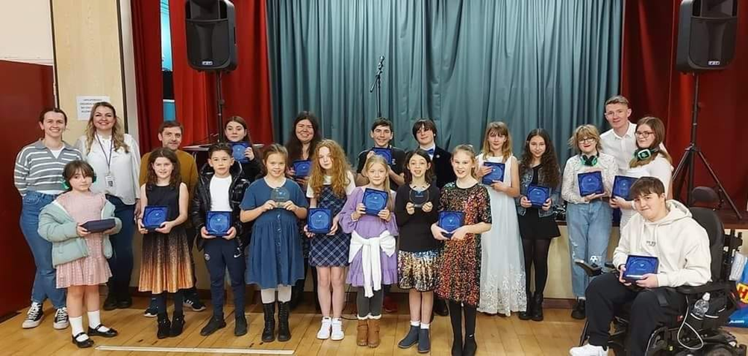

Conclusion & Overview – Ambassadors

This academic year has seen our biggest rise in numbers of ambassadors joining the Essex team which is testament to having a fully operational team in place who have been able to build those relationships and connections with young people. Although we still have a legacy of the North Essex birthplace of the multi-schools council, we are starting to see more ambassadors join from different parts of the county although this is still something to build on.

With so many different working groups in place we have by proxy become more diverse however this also remains something we can improve. We will be re-engaging on a more consistent level with specialist provisions across the county to focus on best practice when capturing the thoughts and feelings of young people with severe and complex needs. We believe what the evidence above shows is how both individually and collectively our ambassadors are stretching the boundaries, and our work is so much more than just working within education. A real growing strength is our ability to connect with services across the SEND systems and as well as areas of improvements we feel these strengths also need to be built upon.

Team projects & highlights

Before we come to our final summery and next steps there are still some important pieces of work to highlight within this report starting with our school awards programme.

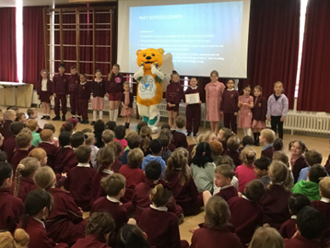
Launched officially in March 2024, the aim of the programme is to give young people a voice in whole school inclusion. This has been developed through past inclusion projects within our ambassador group but is also alongside the Essex inclusion strategy and the Ordinary Available offer. The awards programme has three levels (Bronze, Silver and Gold) which involves evidence being shared in documents, virtual and an in-person visits. At each step young people will be at the heart of feedback, with schools being scored against a matrix which has been designed with young ambassadors.

Since its launch we have had 65 schools sign up and the following have already achieved their Bronze status:
- Holland Park
- Elsenham
- Doucecroft
- Shenfield St Mary’s
- Great Easton
- Beckers Green
- Hogarth

The awards have been very positively received among our most engaged schools and this will help us to start targeting those schools who may be signed up with us but are not engaging to the same levels. Over time we hope to use some of good practice shared and feed this back into the system to help guide other schools on inclusion improvements whilst ensuring young people are central to that.

The East of England SEND network has commissioned the MSC to lead on a regional piece of work, helping connect young people with SEND from across the East of England & ensure their voices are being heard. The network, now named Voices Of The East (VOTE), was launched in November and has already:

- 289 CYP involved within virtual and in person sessions.
- The name created.
- A logo created.
- Mental chosen as their focus topic.
- Cross local authority meetings in person.
- A YouTube channel launched (see reference list).
- Resources to support mental health focused lessons being created.
- A regional wide conference being planned for 2025.

Bringing the focus back to Essex, 35% of the overall engagement of young people has come from our local area, which is the highest compared to the other 10 local authorities. As a result of our work other local areas are also looking to replicate their own MSC models, which is something we want to accelerate, with the support of centralised funding, over next 12-months.

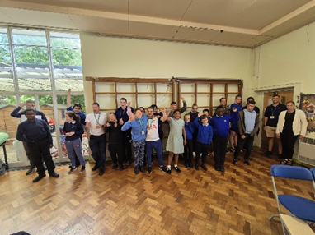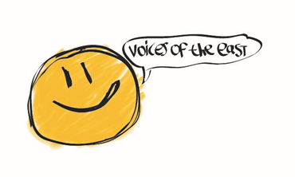
The good practice seekers project continues to run and influence other areas too! In brief the project was originally launched back in 2019 in collaboration between the Essex Youth Service, SENDIASS and us. The idea had initially come from a youth project in Sheffield, with the aim of creating equal opportunities within education.

This aim generated a checklist that young people designed which could be used across primary and secondary schools. The project involves young people receiving training, which can be adapted to meet different groups needs, before they visit other local schools and give feedback on what is working well but what could also be more inclusive. After a couple of terms, the group would then visit the setting again to see if those improvements had been actioned.

The sessions have evolved other time with the Youth Service continuing to deliver their own model and the Education participation & strategy team using it as part of monitoring the early development of the Ordinary available offer. Since its creation we have trained 26 ambassadors as good practice seekers & have involved 29 different schools in either training or visits, with more sessions booked for the new academic year. The most recent visits were lead by our team this academic year with a PPT being produced on its impact (see reference list).
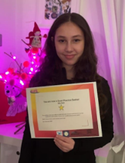

Partnership working is central to everything we do, as we know young people’s voices need to be at the heart of every service. Our team presentations have stretched wider across Essex than ever before including new links being created in social care. For the first time we have also directly spoken with inclusion partners and engagement facilitators at quadrant-based meetings. The impact of this has resulted in colleagues from across education now being allocated to our engagement meetings from September, with interest from health partners too about engaging in these meetings. We have picked up relationships with several academy trusts also that have previously been harder to reach and therefore expand our delivery into different schools from September.
Working with School SENCOs was an area identified by our ambassadors last summer as being crucial to our wider work. The team has since worked with them to dig a little deeper and understand why they think they are so important which was again put into a PPT (see reference list). Not only was this work shared in quadrants at the spring SEND roadshows, but the role of a school SENCO plays a crucial part of our new awards programme detailed at the start of this section. Even wider feedback will be gathered from the engagement meetings in the new academic year.

School attendance is certainly something that remains high on our agenda also. Following our 2022 report on school attendance (see reference list) we continue to work with teams across sectors to again reiterate the need to listen to young people on this subject. In North Essex we have been specifically asked to produce some video feedback from young people which is currently being collected and will be available for the new academic year. We have been involved with the specialist attendance team, working as part of a wider group on resources for schools using elements of our report. Wider than just attendance we know attendance at school links into inclusion and therefore the report has also been used recently as part of the inclusion strategy pillar on attendance, more specifically our CYP framework at the back of the report that could be part of the review process and has helped influence the development of our good practice seekers model. Finally on attendance, we have also created new links with 2 pupil referral units in both South and Mid Essex resulting in audio recordings about their educational experiences that we will be looking to use, again within the new academic year.

Staying on the theme of alternative provisions our team have also been working closely with NECCA in North Essex. This project has been in collaboration with SENDIASS as we looked to identify ambassadors within this setting who could help us to understand their journey and become more diverse. However, as the project has developed it is clear not every young person who works with us wishes to be an ambassador, but we know their views are just as important. The project has now been adapted and will continue with termly drop-ins to ensure young people in alternative provisions still have a voice. For more information on what has been achieved so far, with a report pending, please see our reference list for details.
We won a national SEND co-production award! We can’t write this report without mentioning the wonderful achievement of the team. For the first time ever, the NHS recognised SEND specific work across the country and after we were nominated by a regional lead within health, we picked up the top prize! The award is great recognition for all the work the ambassadors do, especially in helping health services improve locally and one the whole of Essex should be proud of!
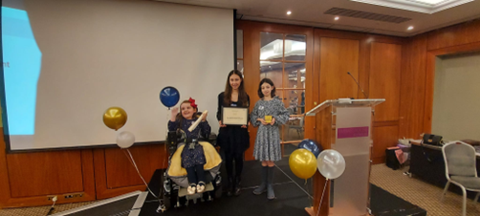
We have also helped launch a new SEND football league in collaboration with Active Essex & the Essex FA. Young people in special schools identified to us that their opportunities to play competitive football games against other schools were much more restrictive than those in mainstream settings. On top of this, the pathways to play football at higher levels also seemed limited for those with neurological differences and therefore we hope this league will start to create this locally and then nationally. The first games of this league will begin in September 2024 and will form part of the official Essex schools football site (see reference list).

Conclusion and next steps

Biggest strengths from this year include:

- An improved process of feedback to schools following our engagement meetings across Essex.
- A bigger involvement across the board when it comes to Essex inclusion work.
- The improved feedback from our school delivery work.
- The number of ambassadors delivering their own SEND awareness sessions and the impact this is having.
- Our work within autism and the various projects linked to the team.
- Launching the school awards programme and how it’s been perceived by schools.

Biggest areas of improvement still needed:

- More diversity within our cohort of ambassadors.
- More ambassadors equally spread across different areas of Essex.
- A bigger focus on neurodiversity.
- Increasing equal attendance across our Essex engagement meetings.
- Increased system impact based on various pieces of work.

Going into the new academic year we will be looking at various projects to address some of the above and beyond:

- Increased engagement with SLD special schools, making sure we are capturing the voices of young people who are non/preverbal.
- Developing links with young people who are educated at home and capturing their voices.
- Develop our focus on school attendance again, alongside whole school inclusion through targeted work and feedback from our school awards programme.
- Create awareness-based feedback linked to rare syndromes and medical conditions.
- Ensure our work is observed and monitored by other teams we work with.
- Develop resources around sensory needs.

On behalf of everyone associated with the MSC, we want to thank you for reading our report. BUT please don’t just ‘read it’ – how could you use it within your everyday work to ensure young people have a voice within your sector? How can this report shape what you do next?

North & South Essex specific – Kayleigh.osben@essex.gov.uk

Mid & West Essex specific – Amy.gair@essex.gov.uk

Countywide – Kierran.pearce@essex.gov.uk

(Reference list on the following pages)

Reference list

Engagement meeting minutes - https://www.multischoolscouncil.org.uk/minutes/

Exams report - https://www.multischoolscouncil.org.uk/exam-report/

Outdoor learning PPT – Email Amy.Gair@essex.gov.uk

Physical Activity PPT – Email Kayleigh.Osben@essex.gov.uk

You can talk original song - https://www.youtube.com/watch?v=FPvYwCSWVsI

National Curriculum report – Email Kayleigh.Osben@essex.gov.uk

Inclusion PPT – Email Kierran.Pearce@essex.gov.uk

YouTube Channel - https://www.youtube.com/@themulti-schoolscouncil7380/featured

Happiness report – Email Amy.gair@essex.gov.uk

Information on our young people’s delivery sessions – Email Kierran.Pearce@essex.gov.uk

Information on our staff delivery sessions – Email Kierran.Pearce@essex.gov.uk

Facebook - https://www.facebook.com/multischools

Instagram - https://www.instagram.com/the_multischools_council/?hl=en

Video feedback - https://www.multischoolscouncil.org.uk/our-videos/

School feedback – Email Kierran.pearce@essex.gov.uk

PACT - https://www.pactforautism.org.uk/

Dyspraxia foundation - https://www.dyspraxiafoundation.org.uk/

National autistic society - https://www.autism.org.uk/

KIDS - https://www.kids.org.uk/ & https://send.essex.gov.uk/search-support-groups-and-activities/kids-autism-hub#:~:text=The%20Kids%20Autism%20Hub%20is,autism%20guides

Waiting for an assessment PPT – Email Kierran.pearce@essex.gov.uk

Youth Sports Trust - https://www.youthsporttrust.org/

Council for disabled children - https://councilfordisabledchildren.org.uk/

Voices of the East - https://www.youtube.com/channel/UCUxCphQy5IPCmy50wEWQQNg

Good practice seekers PPT – Email Kayleigh.Osben@essex.gov.uk

SENCO’s PPT – Email Kayleigh.Osben@essex.gov.uk

School attendance report – https://www.multischoolscouncil.org.uk/attendance-report/

Alternative provision report – Email Amy.Gair@essex.gov.uk

SEND football league (coming soon) - https://www.essexfa.com/cups-and-competitions/schools-cups

