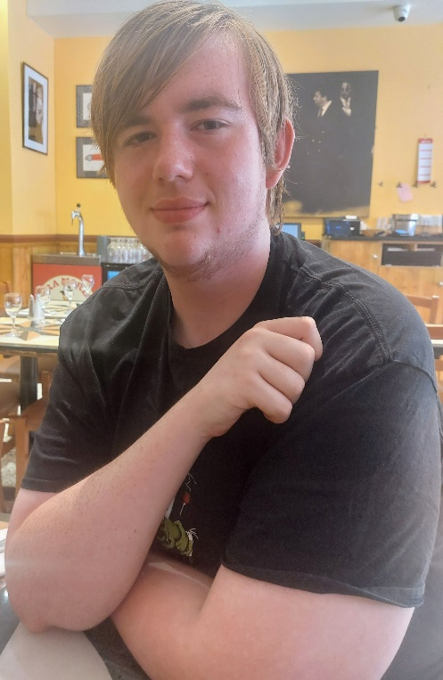

My name is Ellis Walker and I am 19 years old, I am in my final year at school in Cambridge studying for my A levels. As an autistic person, I champion neurodiversity and equality for all children and young people with disabilities. I am proud and excited to be part of the new experts by experience team!

Navigating my own educational journey while living with autism as a young adult in Hertfordshire presents unique challenges and opportunities. I started my school life in a mainstream school, transitioned to a specialist SEMH provision and finally to an out of county specialist autism provision. I have had an EHCP from Hertfordshire from the very start of my school life and have a vast range of experience with SEND in general. I have faced many challenges along the way but am proud that I have a place at University in September to study clinical psychology.

Overcoming challenges is an intrinsic part of the journey for young adults with disabilities. Advocating is very crucial for everyone involved with SEND. Having a voice at the table can change the educational landscape for individuals with disabilities like me. I hope to make a meaningful impact on others through my own experiences and help other young people to have their voices heard.

A little bit about me. I live in Hertfordshire with my parents and my pet family-Porridge my guinea Pig, Trevor the tortoise and Storm the cat.

The things I love most in life are guinea pigs, psychology and Warhammer. When I have any free time, I can be found painting or chatting and playing games.