Freddie Botha Biography
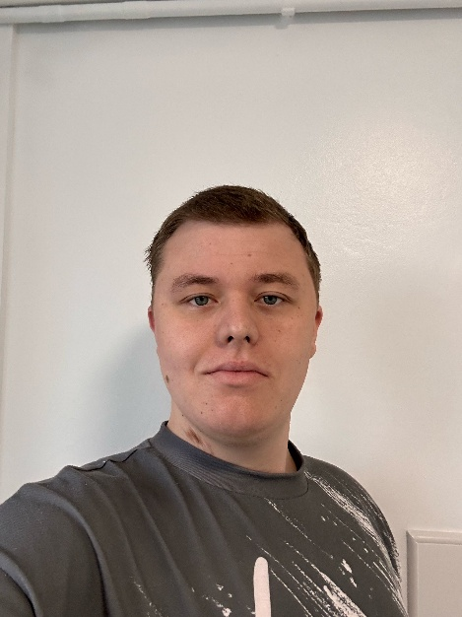
My name is Freddie Botha, and I am 19 years old. I have had a heart transplant and have been diagnosed with Becker muscular dystrophy. As a result of my heart transplant and condition, I have also faced significant mental health challenges. I lived in Hemel Hempstead for almost nine years, but I have recently moved to Berkhamsted.
One of my greatest achievements was passing all my GCSEs during an extremely difficult and low point in my life. I am also proud to have completed my Bronze and Silver Duke of Edinburgh Awards, despite having Becker muscular dystrophy.
My aim in becoming an expert by experience is to use my voice to help communicate the needs of young people and improve the services that SEND already provides. This role aligns with my aspirations, as I want to continue learning and developing as a person while making a positive impact on society. My goals as an expert by experience include gaining new skills, improving the lives of children and young people going through tough times, and making meaningful impacts on others by sharing my story.
I am passionate about supporting children and young people with their mental, physical, or learning difficulties, whether they are facing current challenges or long-term conditions. My goal is to make life a little easier for those going through difficult times by offering my knowledge and experiences.
This year, I hope to achieve two main objectives. First, I want to get to know the people I will be working with so we can build strong, trustworthy relationships. I believe that open communication, active listening, and offering support to one another are key to success. Second, I aim to raise awareness about SEND and the services it offers. When I was in school, I saw many young people struggling with learning difficulties who could have benefited from SEND support but were unaware of it. I want to ensure that as many young people as possible know what SEND is and how it can help them.

