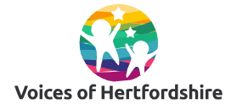
Voices of Hertfordshire primary meeting minutes Holy Family
March 2025

Item | Discussion | Actions
Banjo | As first session introduction to what we talk about in Voices of Hertfordshire through a word search for SEND and Inclusion and an introduction to Banjo. | Young people in school to run Banjo workshop
What is the face saying | Started with looking at a number of photos and choosing a favourite and telling our friends why | Words for discussion:  Mental Health  Sadness  Happiness
- What is a happy face  - What is a sad face  - Can you find happy man, woman, child, girl, boy etc  - Extend to happy boy in wheelchair | Young people shown a sheet with communication in print detailing – What makes you happy? Invited to draw / talk about / write about what makes them happy and then take part in filming if they wished | What is happiness?
Also time to discuss condition and impact as first session. One video created as a result of this with Emilio: https://youtu.be/s2bdMoipYKM

Any questions please let Sarah know on sarah.stevens2@hertfordshire.gov.uk

